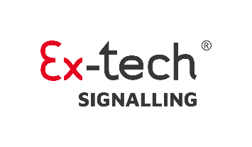
ARTICLE – For Channel Partners - May 2025
Explosion-Proof Sounders for FPSO Safety: Trusted Solutions from Ex-tech Signalling

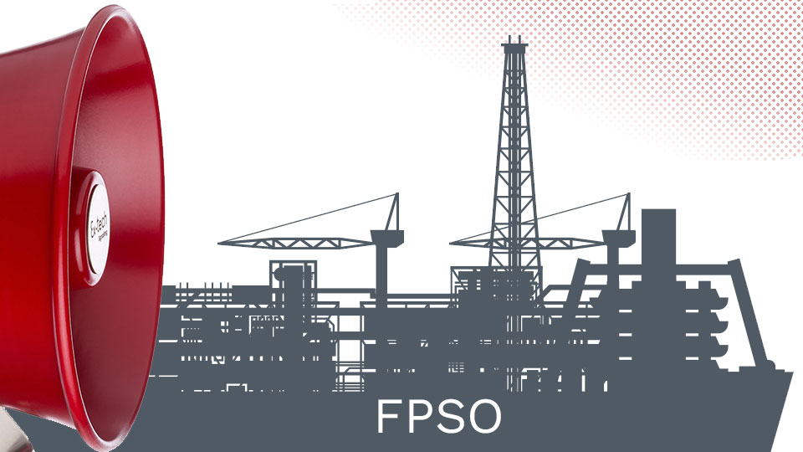

As a supplier of Ex-tech Signalling products, we know how vital reliable safety systems are in offshore environments - especially on FPSO units, which operate as floating facilities for extracting, processing, and storing hydrocarbons in some of the world’s toughest conditions.
FPSOs are now central to offshore operations in regions like Brazil, West Africa, and Southeast Asia. Their mobility suits marginal fields - but also demands reliable safety systems.
Explosion-proof sounders are key. Paired with Ex-tech Signalling’s beacons and call points, they deliver fast, clear alerts to keep crews safe.
In hazardous zones, standard sounders pose ignition risks. That’s why we supply Ex-tech Signalling’s ATEX, IECEx, and now SIL2-certified signalling devices including sounders, call points, and flashing lights - built for safety in the toughest environments.

Multi-Function Sounders for Offshore Safety
Ex-tech Signalling’s sounders are designed for more than just fire or gas leak warnings. They support multilingual crews during evacuations, signal equipment malfunctions, and manage routine operations like shift changes. With programmable tones and sound patterns, they help ensure that alerts are clear, distinct, and actionable - especially when every second counts.

GRP and Stainless Steel Options
When specifying sounders, material choice is crucial. Ex-tech Signalling offers both 316L stainless steel and glass-reinforced polyester (GRP) options. While stainless steel is known for its strength and corrosion resistance, GRP offers a lightweight, low-maintenance alternative that’s gaining popularity among FPSO operators looking to reduce lifecycle costs.

Built to Endure Offshore
Ex-tech Signalling’s sounders are engineered to meet the highest standards, including IP66/IP67 ratings and SIL2 certification. Each unit undergoes rigorous testing including vibration, salt spray, and thermal cycling, to ensure it performs reliably in extreme offshore conditions.

Seamless Integration with Modern Safety Systems
These sounders are designed to integrate with broader safety systems, including gas detection, fire alarms, and emergency shutdown protocols. This allows for automated responses and tailored audio signals that reduce alarm fatigue and improve response times.

Why We Supply Ex-tech Signalling Products
With thousands of successful deployments and a UK-based manufacturing facility, Ex-tech Signalling is a leader in explosion-proof signalling solutions, and is part of the Pioneer Safety Group. Their commitment to quality, innovation, and offshore safety makes them our go-to partner for oil and gas projects.
We’re proud to supply Ex-tech Signalling’s products to our customers and support them in selecting the right solutions for their specific operational needs.

Get in Touch
To learn more about how we can support your FPSO or offshore safety systems with Ex-tech Signalling products, please contact:
[Key Contact’s Name]
📧 [Email Address]
📞 [Phone Number]

