**Social Media**

**Post 1 - FPSO**

[***Download Image here***](https://ex-techsignalling.com/wp-content/uploads/2025/05/FPSO-Ex-tech-Signalling.jpg)

We’re proud to supply **[insert LinkedIn profile “@Ex-tech Signalling”]** sounders and beacons - trusted devices in safety systems across offshore oil and gas installations.

As FPSOs operate in some of the harshest environments, equipment reliability becomes critical. Ex-tech Signalling’s **#ATEX #IECEx, #SIL2 certified #Sounders** are built to perform in high-risk zones, helping crews respond quickly and safely.

To learn more about how we can support your FPSO or offshore safety systems with Ex-tech Signalling products, please contact**:** **[insert email]** and/or **[insert company LinkedIn profile]**

**#FPSO #OilandGas #ChannelPartner**

**Post 2 – GRP vs Stainless Steel**

[***Download image here***](https://ex-techsignalling.com/wp-content/uploads/2025/05/GRP-vs-Stainless-Steel-Ex-tech-Signalling.jpg)

While stainless steel remains a common specification, GRP is gaining ground for its low maintenance and lifecycle cost benefits. And with **#SIL2** certification now standard, performance is never compromised with **[insert LinkedIn profile “@Ex-tech Signalling”]** products.

Not sure which material is right for your operation? **[insert company LinkedIn profile]** will help you choose the best solution.

We’re an official **#ChannelPartner** of Ex-tech Signalling – supporting hazardous area safety systems across the globe.

**#FPSO #OilandGas #ATEX #IECEx #Sounders**

**Post 3 – Sil2 Pushbuttons**

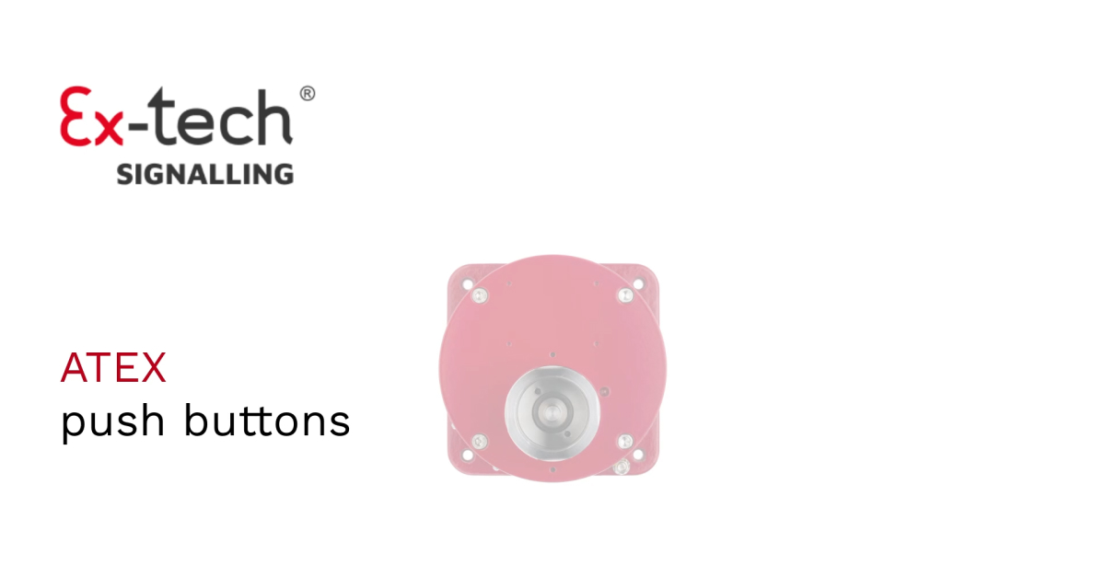[***Download video here***](https://ex-techsignalling.com/wp-content/uploads/2025/05/SIL2-pushbuttons-Ex-tech-Signalling.mp4)

We’re proud to supply a robust range of #**ATEX/IECEx** and now #**SIL2** certified signalling devices - including pushbuttons, sounders, flashing lights, and call points - built for the most demanding environments.

All products are manufactured in the UK, ensuring quality and reliability. We’re ready to support your safety-critical applications in **[#Insert Region]**.

**[insert LinkedIn profile “@Ex-tech Signalling”] #IndustrialSafety**